**HO CHI MINH CITY UNIVERSITY OF TECHNOLOGY AND EDUCATION**

FACULTY FOR HIGH QUALITY TRAINING

**WEB PROGRAMMING**

---------------o0o---------------



**THE WEB PROGRAMMING PROJECT REPORT**

**Content: School Management**

**Lecturer: Nguyen Duc Khoan**

**Group:**

**Vũ Tuấn Anh - 17110004**

**Trương Minh Quân - 17110069**

**Phạm Vũ Thiện - 17110075**

**Ho Chi Minh, December, 2019**

***Comment***

……………………………………………………………………………………………………………………………………………………………………………………………………………………………………………………………………………………………………………………………………………………………………………………………………………………………………………………………………………………………………………………………………………………………………………………………………………………………………………………………………………………………………………………………………………………………………………………………………………………………………………………………………………………………………………………………………………………………………………………………………………………………………………………………………………………………………………………………………………………………………………………………………………………………………………………………………………………………………………………………………………………………………………………………………………………………………………………………………………………………………………………………………………………

# FOREWORD

In the first words of this end-to-end of "Project 1" report, we would like to give our sincere thanks and gratitude to all those who have supported and provided us with knowledge and spirituality during project implementation.

We would like to express our thankful to Mr. Khoan, lecturer at Ho Chi Minh City University of Technology and Education.

Since knowledge is unlimited but ours acknowledge is limited, this program might contain unexpected out-coming. We would like to receive feedback from you in order that we could have more experience to implement our project better.

Best regards!

Ho Chi Minh City, December, 2019

## TABLE OF CONTENT

**FOREWORD 1**

TABLE OF CONTENT 2

**CHAPTER I: PROJECT DESCRIPTION 3**

1. Objective 3

2. User benefits 3

3. Use case diagram 3

4. Advantages and Disadvantages 3

**CHAPTER II: TECHNOLOGY** 9

1. Microsoft SQL Server Management Studio 9

2. Visual Studio 2019 9

**CHAPTER III: DESIGN** **10**

1. ERD Model 10

2. SQL Diagram 10

3. UI Design 11

**Chapter IV: References 12**

**Link youtube demo our project: 12**

# CHAPTER I: PROJECT DESCRIPTION

1. **Objective**

Design an web application which helps user to manage student and teacher throught the admin

1. **User benefits**

You can easily manage student, teacher, and course.

1. **Use case diagram**

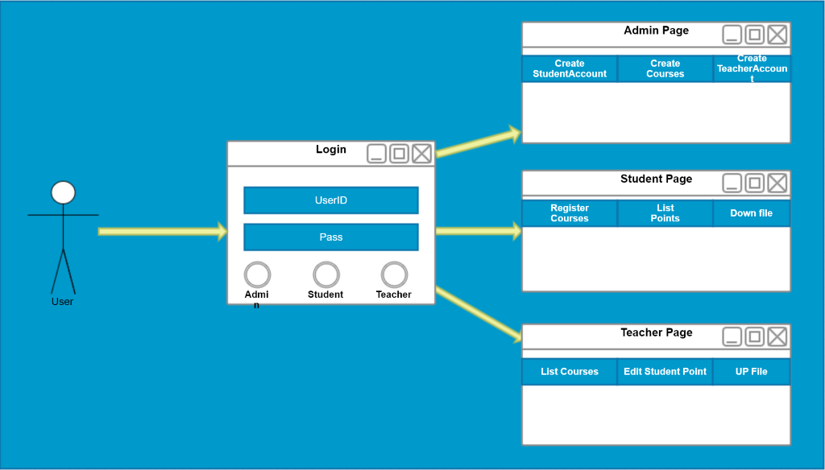

## Advantages and Disadvantages

1. **Advantages**

* Easily to manage the huge schooling system
* Easily to use because user interface friendly

1. **Disadvantages**

* There are some minor errors that occur.

1. **Assignment of work**

|  |  |  |
| --- | --- | --- |
| **Name** | **Assignment** | **Jobs** |
| Trương Minh Quân 17110069 | Published page, Users requirements and Teacher Requirements. | 1. **Published page:**   When non-authenticated users visit website, the website will show all subjects which this school offers for training. The information of each subject includes subject name and a link. Click on the link, the system will direct to another page which shows a short description of the following subject.   1. **Users requirements:**   For users who have account, there are things that they can do.   * 1. Login:   Users, in general, can login to the system before doing their tasks by clicking on ‘Login’ section on navigator bar and typing their username and password. After pressing ‘Login’ button, depending on their type (0: admin, 1: teacher, 2: student), the system will direct to corresponding page.   * 1. Logout:   When users finish their tasks, they can logout the system by click ‘Logout’ section on navigator bar. After that, the system will direct users to Login page.   * 1. Change password:   Users can change their password by clicking on ‘Change password’ section on navigator bar. Users have to type their old password and the desired one, errors will be announced if users type something incorrectly. Otherwise, the system will alert users that ‘Successfully’ and direct users to Login page.   1. **Teacher Requirements:**    1. View teaching course:   After login, the first page teachers will see is the list of courses which teachers are assigned to teacher which include: subject name and courseId.   * 1. View students:   At the end of each record in list of teaching courses there is ‘View Students List ‘ link that link to the page which show list of students who enrolled the course. The information in the list of students includes: studentId, students’ name, students’ date of birth and their grade (if any).  In this page, teacher can give grade or edit grade to their students. Teacher can also search and sort list of students by studentId, student name, student date of birth and their grade by typing in the searching textbox and clicking on the sorting buttons above.   * 1. View documents:   At the end of each record in list of teaching courses there is ‘Documents’ link that link to list of documents that have been posted to server by teachers. The information in the list of documents includes: a short description and some buttons in order for teachers to manipulate.  In this page, teachers can download their posted documents by clicking on ‘Download’ link, the document will be downloaded to the computer. Teachers can also manage the documents which is editing, adding and deleting. |
| Vũ Tuấn Anh 17110004 | Student Requirements | 1. **Edit Page**  * In details page, the students can get information about themselves. However, it is unallowable to let student read personal information of their friends. This page also includes some functions which allow student to: * Register course: Student is allowed to enroll a course. Although, it is impossible to allow them delete their course. Therefore, student must think carefully before they assign a course. * List point: In this function, students can know about their enrolled course and the grade which they are received by their teachers. * File: File is a great function which allows students to download the file from their teacher. Student can only download the file from their teacher. It is impossible for them to upload or delete the file in database system.   - Edit: Student is allowable to alter their individual details. This function can allow them to change their personal data and update new of them   1. **Register page**  * In this page, student can enroll a course by filling two information. Firstly, the course chosen. Next is their student ID. * After entering course ID and student ID, they can click Create to save their information. This will help them enroll the course successfully. * Information about the enrolled course will be updated into the List Point page. Which will show them not only their courses but also the grade from teacher  1. **Edit page**  * In this page, student is allowable to change their personal information. Such as their phone number.  1. **List grade page**  * In this page, student can know about the course enrolled. Besides that, they can download the documents relating to the course. It is essential for student to manage their subjects and related documents.  1. **ListDocs page**  * In this page, student is able to do some functions. For instance: download file, watch details and delete the file |
| Phạm Vũ Thiện | Admin Requirements, User Requirements | 1. **Admin Requiremnts:**    1. View Admin:  * After login as admin, the first page admins will see is the list of accounts which admin can edit, this will content userId, Password, types. * In this page, admin can modifite the types of user and their are teacher and student   1. View Course: * To know which teacher is teaching kinds of subject, we need the Course View to ‘List the Course’ that is exist, this page have courseId, teacherId, and CourseId * In this page, admin can edit the teacher in each subject that they will teach, or delete the teacher from their subject and replace another one.   1. View Enrollment: * When their is any student attend into the coure they will have the enrollment of that course which content courseId and studentId, to know that student in which class(enrollment) * Admin can only delete the enrollment to remove the student because to attend the class can be regis by student.  1. **User requirements:**   Not like admin, user like an super admin, they can do everything like admin and futhermore they can create admin. |

**CHAPTER II: TOOL**

1. **Microsoft SQL Server Management Studio 2016**

* Version 13.0.159900.1
* It is used for create and storage database. Futhermore to create data diagram

User interface

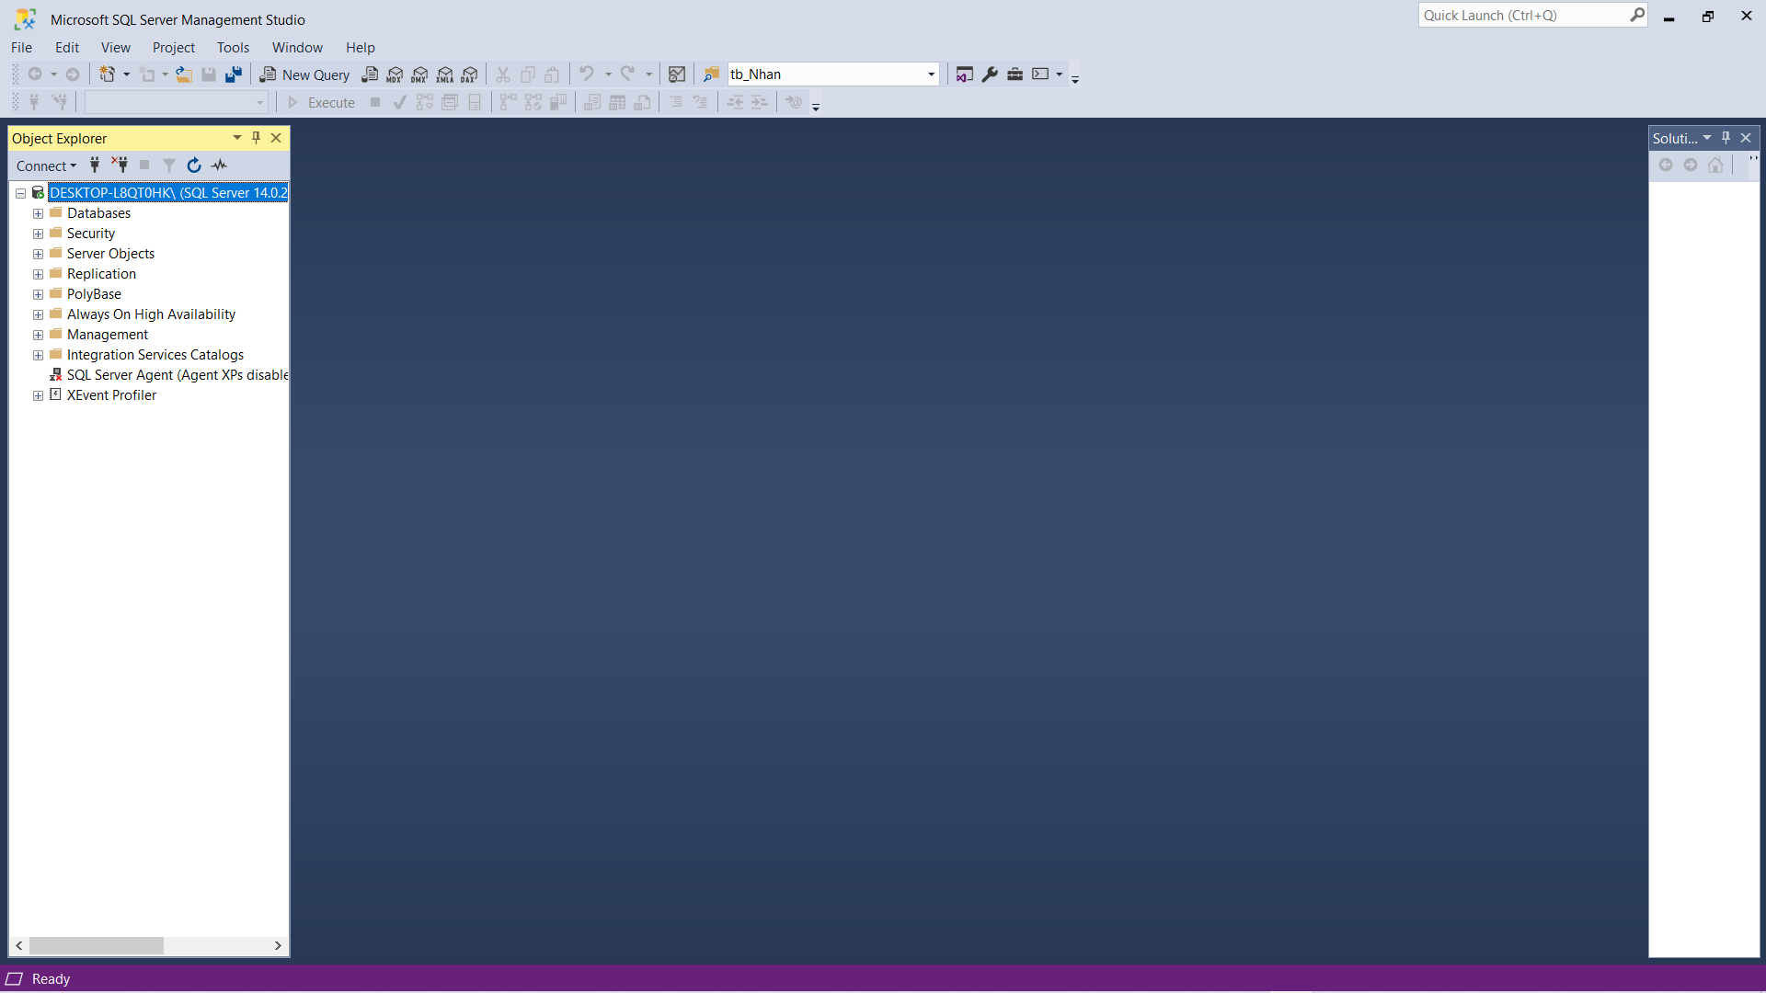

1. **Visual Studio 2019**

* Version 16.4.1
* User Interface of Visual studio 2019

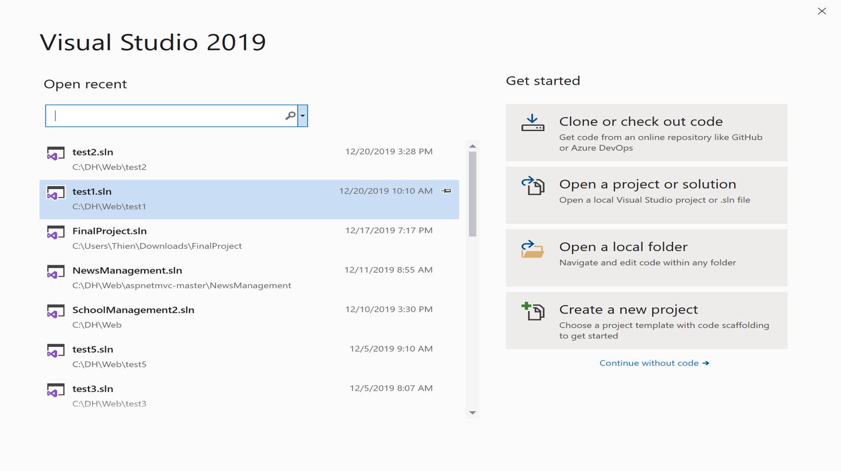

**CHAPTER III: DESIGN**

1. **ERD Model**

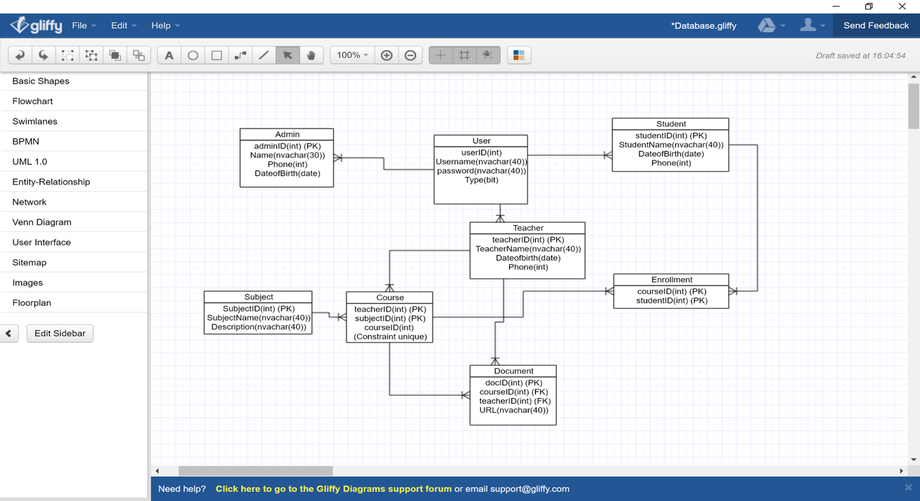

1. **SQL Diagram**

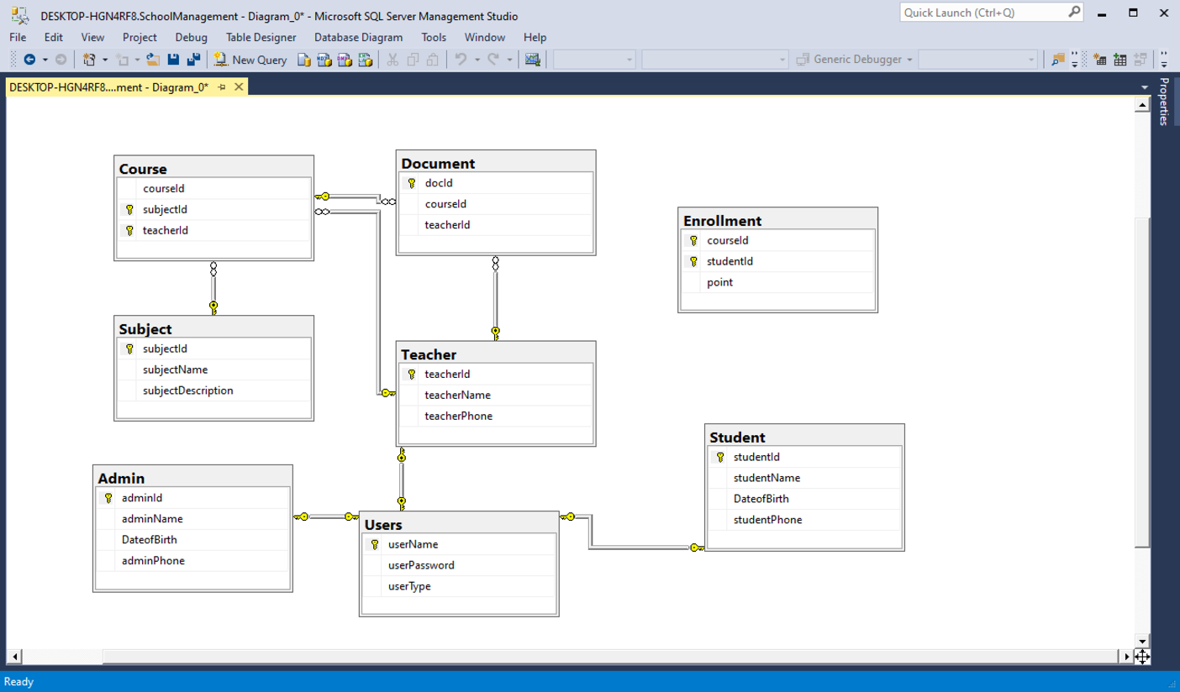

1. **UI Design**

|  |  |  |  |
| --- | --- | --- | --- |
| **Number** | **Screen/Dialog** | **Purpose** | **Describe the reason about the design** |
| 1 |  | Login interface:  Let user login and choses which types of are they. | We want to design as simple as we can, because it vere easily to use. |
| 2 |  | Admin Page  List Account of Teacher and Student | As you can see, it is very easy to see number of account. |
| 3 |  | Teacher Page use to wacth the list student and subject | Watching the total list of student. |
| 4 |  | Student Page: watching Student information | The student can easily see their basic information and they can edit it. |
| 5 |  | Course Page: list subject and teacher who are teaching | For admin to edit the course easiy |
| 6 |  | Enrollment Page:  list student enrolls the course | Watching the grade and course ID, futher more is student enroll |

**Chapter IV: References**

<https://stackoverflow.com/questions/5962557/multiple-primary-key-with-asp-net-mvc-3>

**Link youtube demo our project:**

<https://www.youtube.com/watch?v=9fdGzuIY6AU&feature=youtu.be>